**IEX Cloud Notes - Kevin**

*Getting Started with IEX Cloud* (<https://intercom.help/iexcloud/getting-started/getting-started-with-iex-cloud>)

* Messages are the fundamental unit by which you measure the usage of IEX Cloud data (and calculate associated costs).
* Every “endpoint” has an associated message weight which is found under “DataWeighting” header
* Sandbox testing environment: “Viewing test data” button. This will generate a test API token
* IEX uses REST calls to get data.
* Once start using test calls, you can see your test usage within the IEX Console, including estimated overages

*How to make an API call* (<https://intercom.help/iexcloud/getting-started/how-to-make-an-api-call>)

* You can use HTTPs REST calls to request amd receive back data from IEX Cloud. Every REST call is made up of the base URL, version, and endpoint-specific path, and a query string.

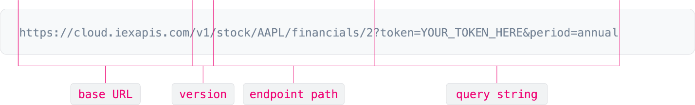

* The base url changes b/w production API and Sandbox API
* The endpoint path is specific to what you want to pull, this part is important to read the documents for in order to get the exact endpoint.
* There are parameters in the endpoint path that can sometimes be optional, this is specified in the documentation
* The query string comes last in a REST call, always begins with a ?. The query string is a series of parameters represented as “parameter = value”. IEX Cloud query strings include the token (sandbox vs production).
* Unless specifically requires secret key, the publishable key should be fine.
* There can be optional parameters in the query string as well

How to find all supported symbols on IEX Cloud. (<https://intercom.help/iexcloud/getting-started/how-to-find-all-supported-symbols-on-iex-cloud>)

* There is an API call to get the full sybmols list from our reference data
* Call returns an array of objects with different fields, such as ticker, exchange, name, date, type, iexID, region, currency, isEnabled.
* Type: CS – Common Stock
* Symbols traded on IEX have real-time and 15-minute market-wide delayed price data available in the Quote and Intraday Prices endpoints.

TOPS/DEEPS – Limit Order Book data on IEX exchange only.